Coffin Bay coastal waters baseline study; report on subtidal soft sediments
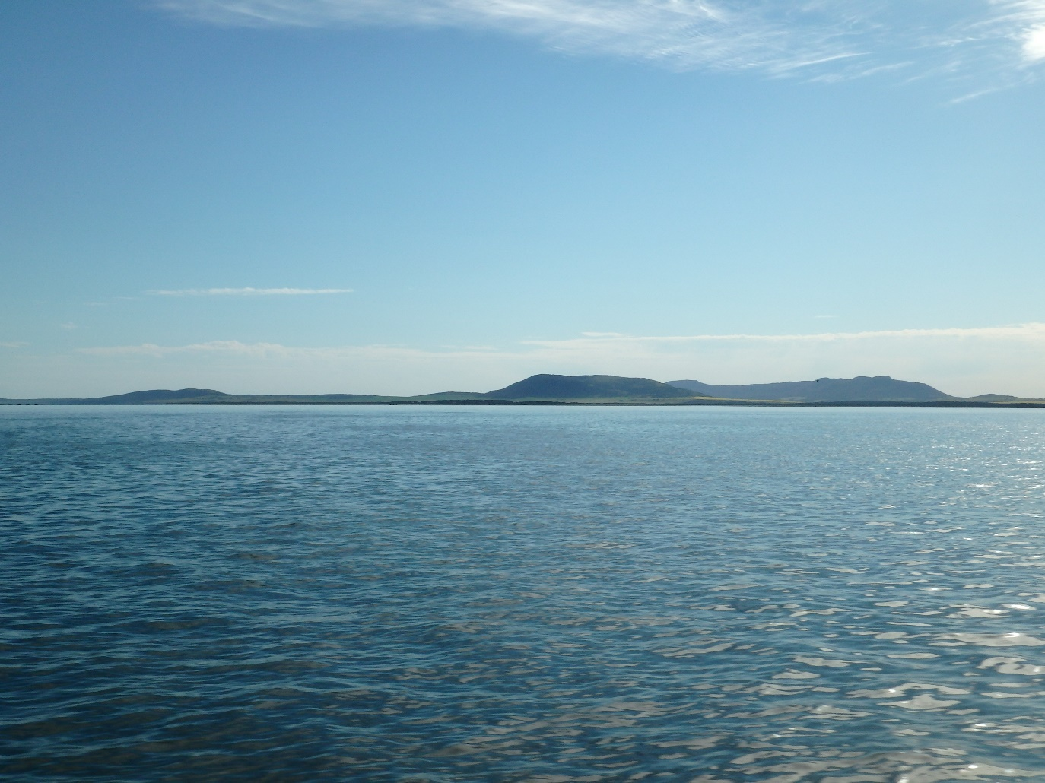

S. Dittmann & R. Baring


Prepared for Department of Environment, Water and Natural Resources and Eyre Peninsula Natural Resources Management Board

Overview
The Coffin Bay coastal waters study was implemented as a baseline assessment of multiple coastal and marine habitats throughout the South Australian Marine Park zones within the open and semi-enclosed bays of the region. This brief summary report provides an assessment of the subtidal soft sediment habitat component of the Coffin Bay coastal waters study. Six subtidal soft sediment sites represented two of each of; General Managed Use Zones (GMUZ), Habitat Protection Zones (HPZ) and Sanctuary Zones (SZ) (Figure 1). Sites were selected based on accessibility within each zone and were distributed by two sites within each zoning type to gain spatial representation of Marine Park zoning in the region. Key benthic macroinvertebrate taxa, species diversity and community assemblages were assessed between zoned sites.

Figure 1: Sampling design used for Coffin Bay coastal waters study of Marine Park zones (SZ, Sanctuary Zone; HPZ, Habitat Protection Zone; GMUZ, General Managed Use Zone). Sites were: Kellidie Bay GMUZ1; Port Douglas GMUZ3, Mount Dutton Bay entrance MDHPZ1; Eely Point between White LADY Rock and Rabbit Island EPHPZ1; Eely Point SZ1; and Kellidie Bay SZ3. Coffin Bay map shows each site location for subtidal soft sediment sites that were sampled during the September 2016 field trips.

Methods
Field sampling across the six subtidal soft sediment sites occurred in September 2016 in water depths ranging from 2 to 7.5 m at distances between 200 and 400 m from shore from the DEWNR vessel “Nuytilus”. At each site, 10 replicate samples were obtained by benthic grab (Ekman grab 225 cm² surface area) and sediment was sieved over 500 µm mesh size to remove fine sediments but retain all macrofauna. Most sites had similar sediment consistency of sand except the MDHPZ1 site, which consisted of very fine anoxic sediment. All macrofauna were fixed in 10 % buffered formalin for transport back to Flinders University. During laboratory processing, samples were rinsed to remove excess formalin residue and macrofauna were sorted, identified to the lowest possible taxonomic level and counted before being preserved in vials of 70 % ethanol for long-term storage.
Macrofauna data were standardised to individuals per m² before diversity indices were calculated (Pielou’s evenness, Shannon Wiener diversity, Simpson’s Index) using the DIVERSE function in PRIMER V.7. Univariate PERMANOVA tests based on the factor of sites were undertaken on Euclidean distance matrices for annelids, crustaceans, molluscs and total macroinvertebrate abundances. Multivariate PERMANOVA was conducted on macroinvertebrate community data based on Bray-Curtis similarities to determine if there was any difference between sites. CLUSTER analyses with SIMPROF tests was also conducted to determine which site and replicate groupings were dissimilar. All macrofauna data were fourth-root transformed before analyses using the PRIMER 7 & PERMANOVA + software package.

Results
Species diversity
In total, 59 taxa were recorded across all sites, which consisted of 18 annelid, 17 mollusc and 16 crustacean taxa (Table 1). The highest numbers of taxa were recorded at the EPHPZ1 and SZ1 sites, while the lowest number of taxa was at the SZ3 site (Table 2). Taxa richness and diversity based on various indices were highest at the EPHPZ1 and SZ1 sites and had the most even contribution across all taxa recorded within those sites (Table 2). In comparison, the species richness, diversity and evenness of taxa represented at GMUZ3 were quite low (Table 2).

Table 1: List of taxa recorded across all six sites throughout Coffin Bay Marine Park Zones.

Table 2: Total number of taxa, abundance of all taxa, taxa richness, evenness of taxa and two diversity indices (Shannon Wiener and Simpson’s) recorded for each site in Coffin Bay Marine Park Zones.

Abundances

Total abundances of all macroinvertebrates were similar and not significantly different between sites (PERMANOVA Pseudo F 1.5, p > 0.05) (Figure 2). There was large variability in total abundances overall with ranges between 4 to > 400 individuals per m². However, abundances of major phyla/higher taxa differed significantly across sites in Marine Park Zones. Abundances of annelids were significantly different between sites (PERMANOVA Pseudo F 6.4, p = 0.001) which was due to the differences between both HPZ sites versus the GMUZ sites and both the SPZ sites versus the GMUZ3 site, where the lowest abundances were recorded (Figure 2). The species contributing most to the higher abundances at HPZ sites were the polychaetes Nephtys sp.1 at MDHPZ1 and Dorvilleidae sp.1 and Orbinidae sp. 1 at EPHPZ1. Molluscs were most abundant at the MDHPZ1 site and significantly different to all other sites (PERMANOVA Pseudo F 3.7, p = 0.006) (Figure 2). The main species contributing to higher abundances at MDHPZ1 was the bivalve Paphies cuneata. Crustaceans were significantly greater in abundance at the GMUZ3 site compared to both HPZ sites and the SZ3 site (PERMANOVA Pseudo F 3.6, p = 0.005) (Figure 2). The higher abundances of crustaceans was mainly attributed to consistently large abundances of amphipods (Gammaridae sp.3, Haustorius sp. 1) and tanaids Tanaidae sp. 1, Apseudidae sp.1). The GMUZ1 site also had significantly higher crustacean abundances than SZ3. Crustacean abundances were also significantly different between the SZ3 and SZ1 sites.

Figure 2: Boxplots (median, 25th & 75th percentiles) of key taxonomic group abundances and total abundances of all taxa recorded at sites in Coffin Bay Marine Park Zones.

Macroinvertebrate community structure
Macroinvertebrate communities were significantly different between most sites (SIMPROF, p < 0.05) except for the HPZ sites which grouped together with similar community structure (Figure 3a). The grouping of the HPZ sites was due to the large contribution of various species of annelids (mainly polychaetes) at those sites (Figure 3b). Each of the GMUZ and SZ sites were unique in macroinvertebrate community structure but some of the main contributors for each of those sites were: GMUZ, the bivalve Paphies cuneata, polychate Nereididae sp.1 and isopod Platynympha longicauda; GMUZ3, tanaids, amphipods and ostracods; SZ1, the polychates Nephtys sp. 1 and Syllidae sp. 1, and amphipods; SZ3, the bivalve P. cuneata, isopod P. longicauda and the polychaete Nereididae sp. 1 (Figure 3b).

(a)
(b)
Figure 3: Macroinvertebrate community structure for six sites throughout Coffin Bay Marine Park Zones with dissimilarity in community structure identified as significant splits by black lines in the (a) cluster diagram based on SIMPROF tests and (b) the same cluster diagram represented with the most abundant 30 taxa contributing to macroinvertebrate communities identified by darker shading on shade plot.
Discussion & conclusion
The high species diversity at the HPZ sites, differences in abundances of some key taxa (notably annelids at HPZ sites) and community structure of those sites with the SZ1 site may be due to sediment type as sediments at the HPZ sites were very fine sand compared to coarser sand around Port Douglas (e.g. GMUZ3). The sites within Kellidie Bay may be different due to a number of different factors that warrant further investigation including freshwater inputs (e.g. groundwater, stream flows), slow tidal flows (> 100 days residency time of water parcels (see Kaempf and Ellis 2015) and accumulation of large amounts of detritus at the GMUZ1 site. Recent oceanographic modelling by Kaempf and Ellis (2015) also indicated that the locations of the studied HPZ sites have a water parcel residency time of about 50 days, which might be more aligned with favourable estuarine conditions for many macroinvertebrate fauna, which line up well with our results from this baseline study.

References
Kaempf J., Ellis H. (2015) Hydrodynamics and flushing of Coffin Bay, South Australia: A small tidal inverse estuary of interconnected bays. Journal of Coastal Research, 31, 447-456.

